**HEALTH MONITORING SYSTEM**

##### 15IT375L- IOT PROJECT REPORT

###### ***Submitted by***

Isha Bansal(Ra1611008010413)

Piyush Raj(Ra1611008010339)

Vardhman Hundia(Ra1611008010541)

Shalini Choudhary(Ra1611008010505)

***for the assessment of 3rd year Minor Project***

in the

# DEPARTMENT OF INFORMATION TECHNOLOGY



**SRM UNIVERSITY**

KATTANKULATHUR

OCTOBER 18TH

**SRM UNIVERSITY**

KATTANKULATHUR

**BONAFIDE CERTIFICATE**

Certified that this Minor project report **ANALYSIS OF VIDEO GAME REVIEWS USING ML ALGORITHMS** is the bonafide work of **Shalini Choudhary, Piyush Raj, Isha Bansal And Vardhman Hundia** who carried out the project work under my supervision at SRM University , IT Department, Kattankulathur.

MS.S.DEEPANJALI

**HEAD OF THE DEPARTMENT Information Technology**

INTERNAL EXAMINER

**DECLARATION**

I **VARDHMAN HUNDIA, RA1611008010541** studying in III year B.Tech Information Technology program at, SRM University, Kattankulathur, Chennai, hereby declare that this project is an original work of mine and I have not verbatim copied / duplicated any material from sources like internet or from print media, excepting some vital company information / statistics and data that is provided by the company itself.

Signature of the Student

Date:

Place:

**DECLARATION**

I **SHALINI CHOUDHARY, RA1611008010505** studying in III year B.Tech Information Technology program at, SRM University, Kattankulathur, Chennai, hereby declare that this project is an original work of mine and I have not verbatim copied / duplicated any material from sources like internet or from print media, excepting some vital company information / statistics and data that is provided by the company itself.

Signature of the Student

Date:

Place:

**DECLARATION**

I **PIYUSH RAJ, RA1611008010339** studying in III year B.Tech Information Technology program at, SRM University, Kattankulathur, Chennai, hereby declare that this project is an original work of mine and I have not verbatim copied / duplicated any material from sources like internet or from print media, excepting some vital company information / statistics and data that is provided by the company itself.

Signature of the Student

Date:

Place:

**DECLARATION**

I **ISHA BANSAL, RA1611008010431** studying in III year B.Tech Information Technology program at, SRM University, Kattankulathur, Chennai, hereby declare that this project is an original work of mine and I have not verbatim copied / duplicated any material from sources like internet or from print media, excepting some vital company information / statistics and data that is provided by the company itself.

Signature of the Student

Date:

Place:

**ACKNOWLEDGEMENT**

The success and the final outcome of this project required guidance and assistance from different sources and we feel extremely fortunate to have got this all along the completion of our project. Whatever we have done is largely due to such guidance and assistance and we would not forget to thank them.

We express our sincere thanks to the Head of the Department, Department of Information Technology, **Dr.G.Vadivu**, for all the help and infrastructure provided to us to complete this project successfully and his valuable guidance.

We owe our profound gratitude to our project guide **Ms.S.Deepanjali** , who took keen interest in our project work and guided us all along, till the completion of our project work by providing all the necessary information for developing a good system.

We are thankful to and fortunate enough to get constant encouragement, support and guidance from all the Teaching staff of the Department of Information Technology which helped us in successfully completing our minor project work. Also, we would like to extend our sincere regards to all the non-teaching staff of the department of Information Technology for their timely support.   
VARDHMAN HUNDIA , RA1611008010541

**ACKNOWLEDGEMENT**

The success and the final outcome of this project required guidance and assistance from different sources and we feel extremely fortunate to have got this all along the completion of our project. Whatever we have done is largely due to such guidance and assistance and we would not forget to thank them.

We express our sincere thanks to the Head of the Department, Department of Information Technology, **Dr.G.Vadivu**, for all the help and infrastructure provided to us to complete this project successfully and his valuable guidance.

We owe our profound gratitude to our project guide **Ms.S.Deepanjali** , who took keen interest in our project work and guided us all along, till the completion of our project work by providing all the necessary information for developing a good system.

We are thankful to and fortunate enough to get constant encouragement, support and guidance from all the Teaching staff of the Department of Information Technology which helped us in successfully completing our minor project work. Also, we would like to extend our sincere regards to all the non-teaching staff of the department of Information Technology for their timely support.   
PIYUSH RAJ , RA1611008010339

**ACKNOWLEDGEMENT**

The success and the final outcome of this project required guidance and assistance from different sources and we feel extremely fortunate to have got this all along the completion of our project. Whatever we have done is largely due to such guidance and assistance and we would not forget to thank them.

We express our sincere thanks to the Head of the Department, Department of Information Technology, **Dr.G.Vadivu**, for all the help and infrastructure provided to us to complete this project successfully and his valuable guidance.

We owe our profound gratitude to our project guide **Ms.S.Deepanjali** , who took keen interest in our project work and guided us all along, till the completion of our project work by providing all the necessary information for developing a good system.

We are thankful to and fortunate enough to get constant encouragement, support and guidance from all the Teaching staff of the Department of Information Technology which helped us in successfully completing our minor project work. Also, we would like to extend our sincere regards to all the non-teaching staff of the department of Information Technology for their timely support.   
ISHA BANSAL , RA1611008010413

**ACKNOWLEDGEMENT**

The success and the final outcome of this project required guidance and assistance from different sources and we feel extremely fortunate to have got this all along the completion of our project. Whatever we have done is largely due to such guidance and assistance and we would not forget to thank them.

We express our sincere thanks to the Head of the Department, Department of Information Technology, **Dr.G.Vadivu**, for all the help and infrastructure provided to us to complete this project successfully and his valuable guidance.

We owe our profound gratitude to our project guide **Ms.S.Deepanjali** , who took keen interest in our project work and guided us all along, till the completion of our project work by providing all the necessary information for developing a good system.

We are thankful to and fortunate enough to get constant encouragement, support and guidance from all the Teaching staff of the Department of Information Technology which helped us in successfully completing our minor project work. Also, we would like to extend our sincere regards to all the non-teaching staff of the department of Information Technology for their timely support.   
SHALINI CHOUDHARY , RA1611008010505

**TABLE OF CONTENTS**

**CHAPTER NO. TITLE PAGE NO.**

**ABSTRACT 12**

**1. INTRODUCTION 44**

1.1 MOTIVATION 45

1.2 DOMAIN INTRO 45

1.3 CLASSIFICATION TECHNIQUES 46

**2. REQUIREMENT ANALYSIS 58**

2.1SYSTEM REQUIREMENTS 58

2.2 MINIUM REQUIREMENTS 58

2.3 REQUIREMENTS 58

2.2 SOFTWARE USED 58

**3. IMPLEMENTATION AND TESTING 59**

3.1 DATA ACQUISTION

3.2 HUMAN LABELLING

3.3 DATA CLEANING

3.4 FEATURE EXTRACTION

3.5 SPLITTING DATASET

3.6 CLASSIFICATION

**4. IMPLEMENTATION AND TESTING 60**

**5. REFERENCES 74**

**6. CONCLUSION 75**

**ABSTRACT**

The design and development of wearable biosensor systems for health monitoring has garnered lot of attention in the scientific community and the industry during the last years. Mainly the motivation lies over the increasing healthcare costs and propelled advancement in miniature biosensing devices, microelectronics and wireless communications. The continuous advancement of wearable sensor-based systems will potentially transform the future of healthcare by enabling proactive personal health management. These systems can comprise various types of small physiological sensors, transmission modules and processing capabilities and thus can facilitate low-cost wearable solutions for all-day all-place activity status monitoring. This project focuses on sensing the temperature and heartbeat of a person which could be monitored over the internet. It enables the doctor to monitor the patient from anywhere at anytime of the world and the assistance could be availed for any major issue.

1. **Introduction**

In the present era of technology everything is becoming technology driven. The health care is vast are requiring continuous monitoring. The design and development of wearable biosensors systems for health monitoring has garnered lot of attention in the scientific community and the industry during the last years. Mainly the motivation lies over the increasing healthcare costs and propelled advancement in miniature biosensing devices, microelectronics and wireless communications. The continuous advancement of wearable sensor-based systems will potentially transform the future of healthcare by enabling proactive personal health management. These systems can comprise various types of small physiological sensors, transmission modules and processing capabilities and thus can facilitate low-cost wearable solutions for all-day all-place activity status monitoring.

Here in this project used to monitor body temperature and heart rate of the patient continuously, doctor can obtain the results in any of their devices using cloud. For any emergency purposes doctors to be properly assist the patient which is very useful for a future treatment of the patient.

##### Requirement Analysis

**2.1 HARDWARE REQUIREMENTS:**

* Node MCU ESP8266
* Temperature Sensor-LM35
* Finger Pulse Rate Sensor

#### 2.2 SYSTEM REQUIREMENTS :

* Processors:
  + Intel® Core™ i5 processor 4300M at 2.60 GHz or 2.59 GHz (1 socket, 2 cores, 2 threads per core), 8 GB of DRAM
  + Intel® Xeon Phi™ processor 7210 at 1.30 GHz (1 socket, 64 cores, 4 threads per core), 32 GB of DRAM, 16 GB of MCDRAM (flat mode enabled)
* Disk space: 2 to 3 GB
* Operating systems: Windows® 10, macOS*, and Linux*

#### 2.3 MINIMUM SYSTEM REQUIREMENTS :

* Processors: Intel Atom® processor or Intel® Core™ i3 processor
* Disk space: 1 GB
* Operating systems: Windows* 7 or later, macOS, and Linux

#### 2.4 SOFTWARE USED :

* Arduino IDE
* MOSUITTO MQTT
* Thinkspeak cloud @ https://thingspeak.com/channels/606138/private_show

1. **DESIGN**

BIOSENSOR

NODE MCU

WIRELESS DEVICE

THINKSPEAK CLOUD

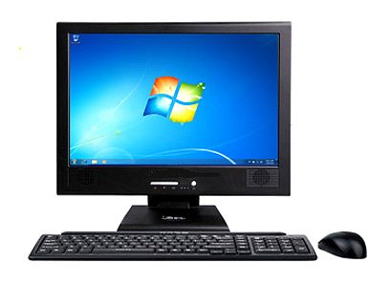

**BIOSENSORS:**

The biosensors sense the change in the body by different mechanisms. the change is variable in nature thus analog signal is been transmitted. The signal is then transmitted over nodeMCU is particular intervals as per the nodeMCU program.

The biosensors used are:

1. **LM35 -TEMPERATURE SENSOR**

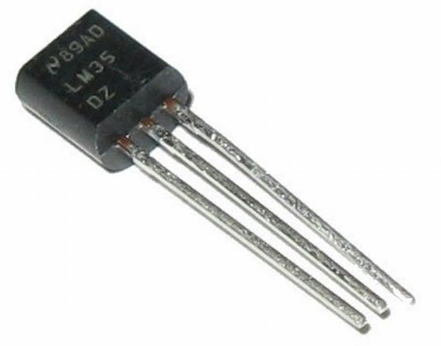

The LM35 is one kind of commonly used temperature sensor that can be used to measure temperature with an electrical o/p comparative to the temperature (in °C). It can measure temperature more correctly compare with a thermistor. This sensor generates a high output voltage than thermocouples and may not need that the output voltage is amplified. The LM35 has an output voltage that is proportional to the Celsius temperature. The scale factor is .01V/°C.

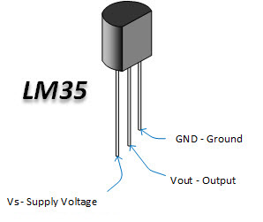

**LM35 Temperature Sensor**

The LM35 does not need any exterior calibration and maintains an exactness of +/-0.4°C at room temperature and +/-0.8°C over a range of 0°C to +100°C.One more significant characteristic of this sensor is that it draws just 60 microamps from its supply and acquires a low self-heating capacity. The LM35 temperature sensor available in many different packages like T0-46 metal can transistor-like package, TO-92 plastic transistor-like package, 8-lead surface mount SO-8 small outline package.

#### Pin Configuration

|  |  |  |
| --- | --- | --- |
| **Pin Number** | **Pin Name** | **Description** |
| 1 | Vcc | Input voltage is +5V for typical applications |
| 2 | Analog Out | There will be the increase in 10mV for raise of every 1°C. Can range from -1V(-55°C) to 6V(150°C) |
| 3 | Ground | Connected to ground terminal of the circuit |

### LM35 Temperature Sensor Circuit Diagram

The LM35 temperature sensor is used to detect precise centigrade temperature. The output of this sensor changes describes the linearity. The o/p voltage of this IC sensor is linearly comparative to the Celsius temperature. The operating voltage range of this LM35 ranges from-55˚ to +150˚C and it has low-self heating. This is operated under 4 to 30 volts. The most extensively used electronic devices are operational amplifiers, which are certain kind of differential amplifiers. Temperature sensor circuit has terminals such as two inputs like non-inverting (+) and inverting (-) and only one output pin. [Operational amplifier](http://www.efxkits.us/how-op-amp-use-as-comparator/) IC741 is used as a non-inverting amplifier. The variation between the i/p terminals amplifies the circuit.

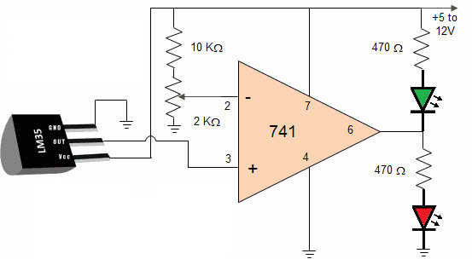

**LM35 Circuit Diagram**

The amount produced by IC2 amplifies in an amount to the temperature by 10 mV per degree. This unstable voltage is supply to a comparator IC 741. OP Amplifier is the most generally used electronic devices today. The IC 741 op-amp is one sort of differential amplifier. We have used IC741 as a non-inverting amplifier which means pin-3 is the input and the output is not inverted. This LM35 temperature sensor circuit amplifies the difference between its input terminals. The advantages of temperature sensor include It has no effect on the medium, more accurate, It has an easily conditioned output and It responds instantly.

1. **KY-039 FINGURE HEART BEAT SENSOR**

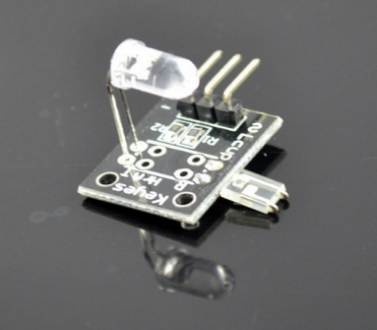

The LED is the light side of the finger, and phototransistor on the other side of the finger, phototransistor used to obtain the flux emitted, when the blood pressure pulse by the finger when the resistance of the photo transistor will be slightly changed.

* Sensor pin S connect to Arduino pin Analoog 0 / A0
* Sensor pin + (middle pin) connect to Arduino pin 5+
* Sensor pin - connect to Arduino pin GND

Taking your pulse is as simple as holding a finger to your neck or wrist and timing the beats with your watch. But if you want to record the data or use it to trigger events, you need to turn that mechanical pulsing action into an electrical signal. This pulse sensor fits over a fingertip and uses the amount of infrared light reflected by the blood circulating inside to do just that.

* **NOTE:** While we think it’s pretty obvious, our lawyer just tapped us on the shoulder and asked us to emphasize that this is not a medical device. If your application is life- or health-critical, please use only an FDA-approved medical-grade pulse sensor, OK? Thanks!

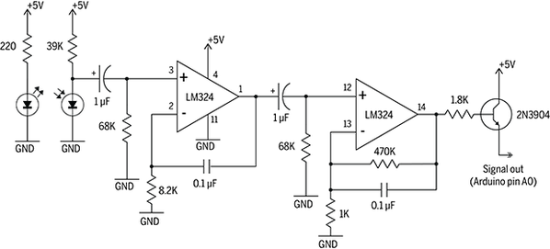

* *Schematic with symbolic op-amp representation.*
* The sensor itself consists of an infrared emitter and detector mounted side-by-side and pressed closely against the skin. When the heart pumps, blood pressure rises sharply, and so does the amount of infrared light from the emitter that gets reflected back to the detector. The detector passes more current when it receives more light, which in turn causes a voltage drop to enter the amplifier circuitry. This design uses two consecutive operational amplifiers (“op-amps”) to establish a steady baseline for the signal, emphasize the peaks, and filter out noise. Both op-amps are contained in a single integrated circuit (IC or “chip”), and hooking them up is really just a matter of interconnecting the pins correctly.
* 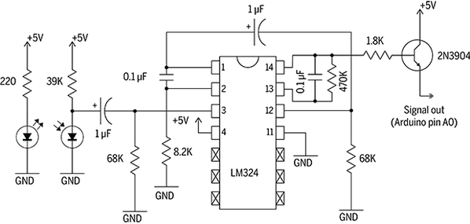
* *Schematic with physical op-amp representation.*
* The two op-amps output a clean but weak signal which is amplified by the transistor before output.
* The complete pulse sensor is a three-wire device that runs on 5V and outputs signal on the white wire. You can visualize and/or record this signal in a number of ways, but we’ve chosen to connect to a personal computer through Arduino, mostly because of the ease of integrating Processing, which in turn is very handy for visualization. But you don’t really need an Arduino to use the sensor

TRANSMITTER:

Now the analog signals received from biosensors are been received over a transmitter. The transmitter transmits the analog value over to the cloud over every specific intervals of time.

Node MCU:

**REFERENCES:**

* Naive Bayes text classification (<http://nlp.stanford.edu/IR-book/html/htmledition/naive-bayes-text-classification-1.html>)
* Spam filtering (<http://en.wikipedia.org/wiki/Bayesian_spam_filtering>)
* Hybrid Recommender System Using Naive Bayes Classifier and Collaborative Filtering (<http://eprints.ecs.soton.ac.uk/18483/>)
* <https://www.cc.gatech.edu/~isbell/reading/papers/Rish.pdf>
* <https://ijcsmc.com/docs/papers/October2014/V3I10201499a33.pdf>

**Conclusion**

This project introduced the concept of sentiment analysis and opinion mining. Firstly the main motive was to first convert the unstructured dataset to a properly organized structured data. The steps involved data cleaning in which the missing words were removed as unorganized test were converted to organized form .After converting them to structural format we used the reviews and class for classifying the obtained review as positive or negative. Then we can perform exploratory data analysis on the given dataset.They were assigned a score of 0 and 1 where 0(negative) and 1(positive).After that the dataset was trained using ml algorithms like naïve Bayes(90%) and logistic regression(92%) in which the accuracy were compared.

Thus we can conclude that the machine learning techniques can be easily applied on our dataset and better accuracy can be obtained.

**END OF THE REPORT**